**Assignment 12 : Group C (Unit V & VI )**

|  |  |  |  |  |  |  |
| --- | --- | --- | --- | --- | --- | --- |
| **W (4)** | **C (4)** | **D (4)** | **V(4)** | **T (4)** | **Total** | **Sign** |
|  |  |  |  |  |  |  |

**Date of Performance ____________**

**Date of Completion** :_____________

**Problem Definition:**

**Prerequisite:**

1. Knowledge about IP and Subnets.

2. Linux basic commands.

**Learning Objectives**:

1. Understand the concept of DHCP.

2. Configuring DHCP and installation of software.

**New Concepts:**

1. Crimping

2. Access Point Configuration

**Theory**

**Introduction**

* DHCP (Dynamic Host Configuration Protocol) is a protocol that lets network administrators manage centrally and automate the assignment of IP (Internet Protocol) configurations on a computer network.
* When using the Internet's set of protocols (TCP/IP), in order for a computer system to communicate to another computer system it needs a unique IP address.
* Without DHCP, the IP address must be entered manually at each computer system. DHCP lets a network administrator supervise and distribute IP addresses from a central point.
* The purpose of DHCP is to provide the automatic (dynamic) allocation of IP client configurations for a specific time period (called a lease period) and to eliminate the work necessary to administer a large IP network.
* When connected to a network, every computer must be assigned a unique address.
* However, when adding a machine to a network, the assignment and configuration of network (IP) addresses has required human action.
* The computer user had to request an address, and then the administrator would manually configure the machine. Mistakes in the configuration process are easy for novices to make, and can cause difficulties for both the administrator making the error as well as neighbors on the network. Also, when mobile computer users travel between sites, they have had to relive this process for each different site from which they connected to a network.

In order to simplify the process of adding machines to a network and assigning unique IP addresses manually, there is a need to automate the task.

* The introduction of DHCP alleviated the problems associated with manually assigning TCP/IP client addresses. Network administrators have quickly appreciated the importance, flexibility and ease-of-use offered in DHCP. **Advantages of DHCP:-**

DHCP has several major advantages over manual configurations.

Each computer gets its configuration from a "pool" of available numbers automatically for a specific time period (called a leasing period), meaning no wasted numbers.

* When a computer has finished with the address, it is released for another computer to use. Configuration information can be administered from a single point.
* Major network resource changes (e.g. a router changing address), requires only the DHCP server be updated with the new information, rather than every system.

**DHCP message types:**

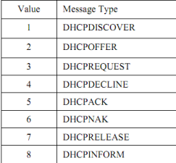

**DHCP Operations:-**

1. DHCP Discover

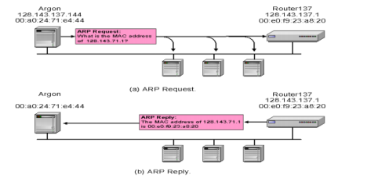

2. DHCP Offer

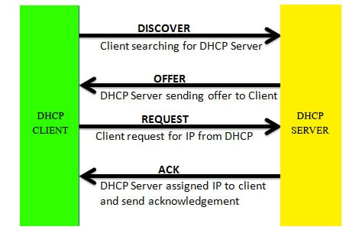

**3.** DHCP Discover: At this time, the DHCP client can start to use the IP address

4. DHCP Release: At this time, the DHCP client has released the IP address

**5.4.4 Installing DHCP in Ubuntu:**

**Open terminal and type following commands:-**

1. sudo apt-get install isc-dhcp-server

2. sudo gedit /etc/dhcp/dhcpd.conf then make changes in file....

default-lease-time 600; max-lease-time 7200;

option subnet-mask 255.255.255.0;

option broadcast-address 10.1.32.255;

subnet 192.168.1.0 netmask 255.255.255.0

range 10.1.32.10 10.1.32.20; }

3. save file and close

4. again on terminal give following commands....

sudo service isc-dhcp-server restart

sudo service isc-dhcp-server start

5. On another PC in Internet properties change to Obtain IP address automatically and then check the IP address.

**Assignment Questions:**

1. What is importance of DHCP?**.**

2. What is a DHCP lease?

3. What protocol and port does DHCP use?

4. What is difference between BOOTP and DHCP?

5. What is a DHCP Scope and why is it required?

6. Which Linux command is used to find your systems IP address?

7. Why to import pxssh Library ?

8. Why to Install Openssh Package?

**Conclusion:**

**Hence we Installed and Configured DHCP and studied Installation of Software on remote Machine.**